**TRACING THE GROWTH OF**

**THE GLOBAL COMMUNITY:**

**A POPULATION**

**FORECASTING ANALYSIS**

1.INTRODUCTION:

1.1 OVERVIEW:

The world’s population is more than three times larger than it was in the mid-twentieth century. The global human population reached 8.0 billion in mid-November 2022 from an estimated 2.5 billion people in 1950, adding 1 billion people since 2010 and 2 billion since 1998. The world’s population is expected to increase by nearly 2 billion persons in the next 30 years, from the current 8 billion to 9.7 billion in 2050 and could peak at nearly 10.4 billion in the mid-2080s. This dramatic growth has been driven largely by increasing numbers of people surviving to reproductive age, the gradual increase in human lifespan, increasing urbanization, and accelerating migration. Major changes in fertility rate have accompanied this growth. These trends will have far-reaching implications for generations to come.

1.2 PURPOSE:

* Population forecasting is defined as the method of determining the expected population for a particular design period of a water supply system with the help of the study and analysis of future events and available records.
* The population is an important parameter that is determined for the design of the water system of a particular area. Water supply systems are designed for a population expected for a certain design period instead of taking into consideration the present population of the area.
* There are several mathematical methods that can be used to determine the population for a design period.

2. PROBLEM DEFINITION & DESIGN THINKING:

2.1 EMPATHY MAP:

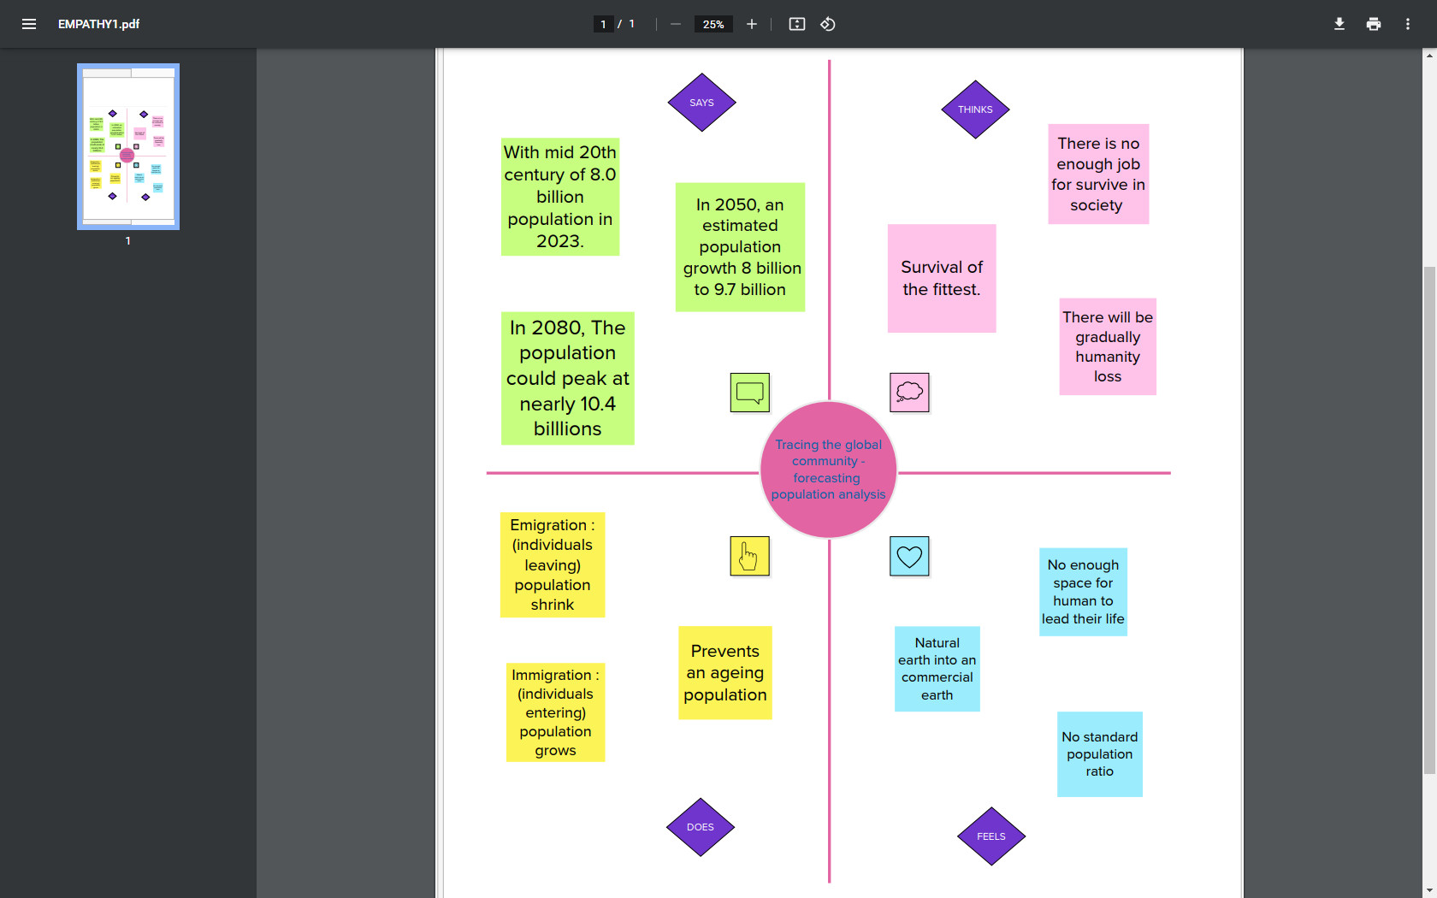

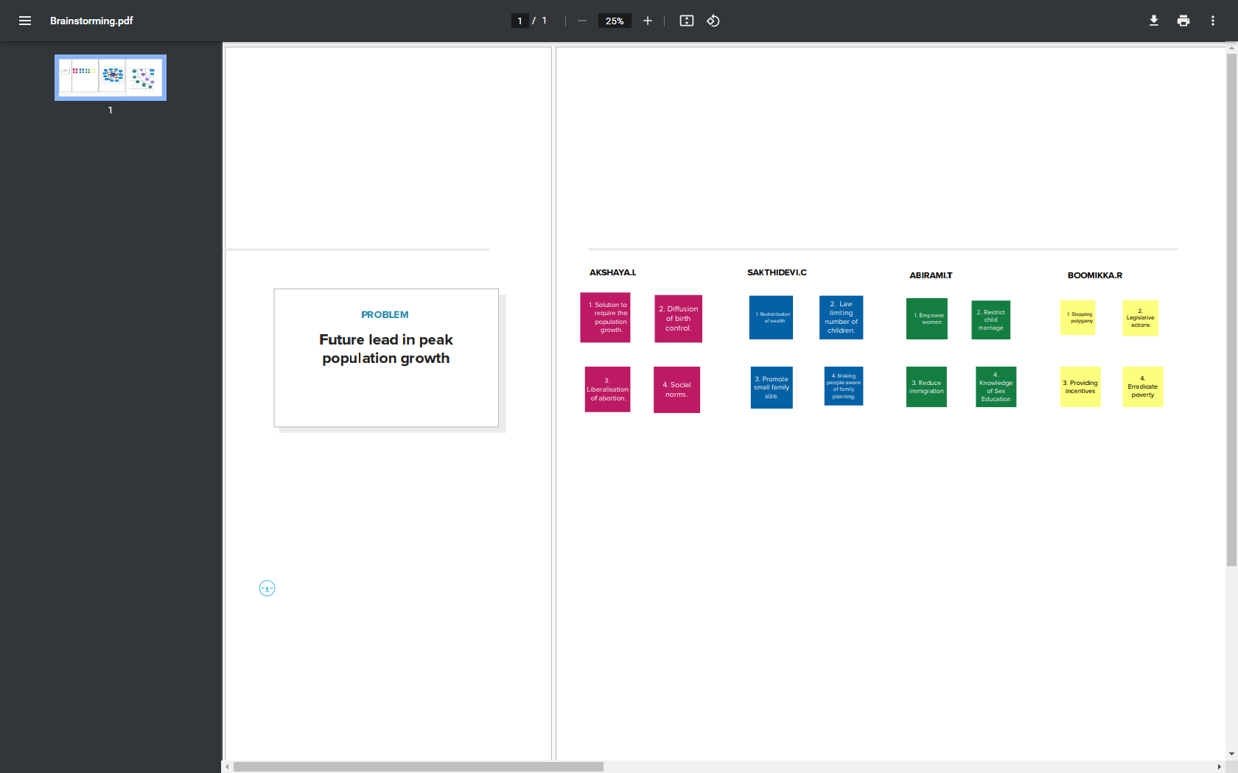2.2 IDEATION AND BRAINSTORMING:

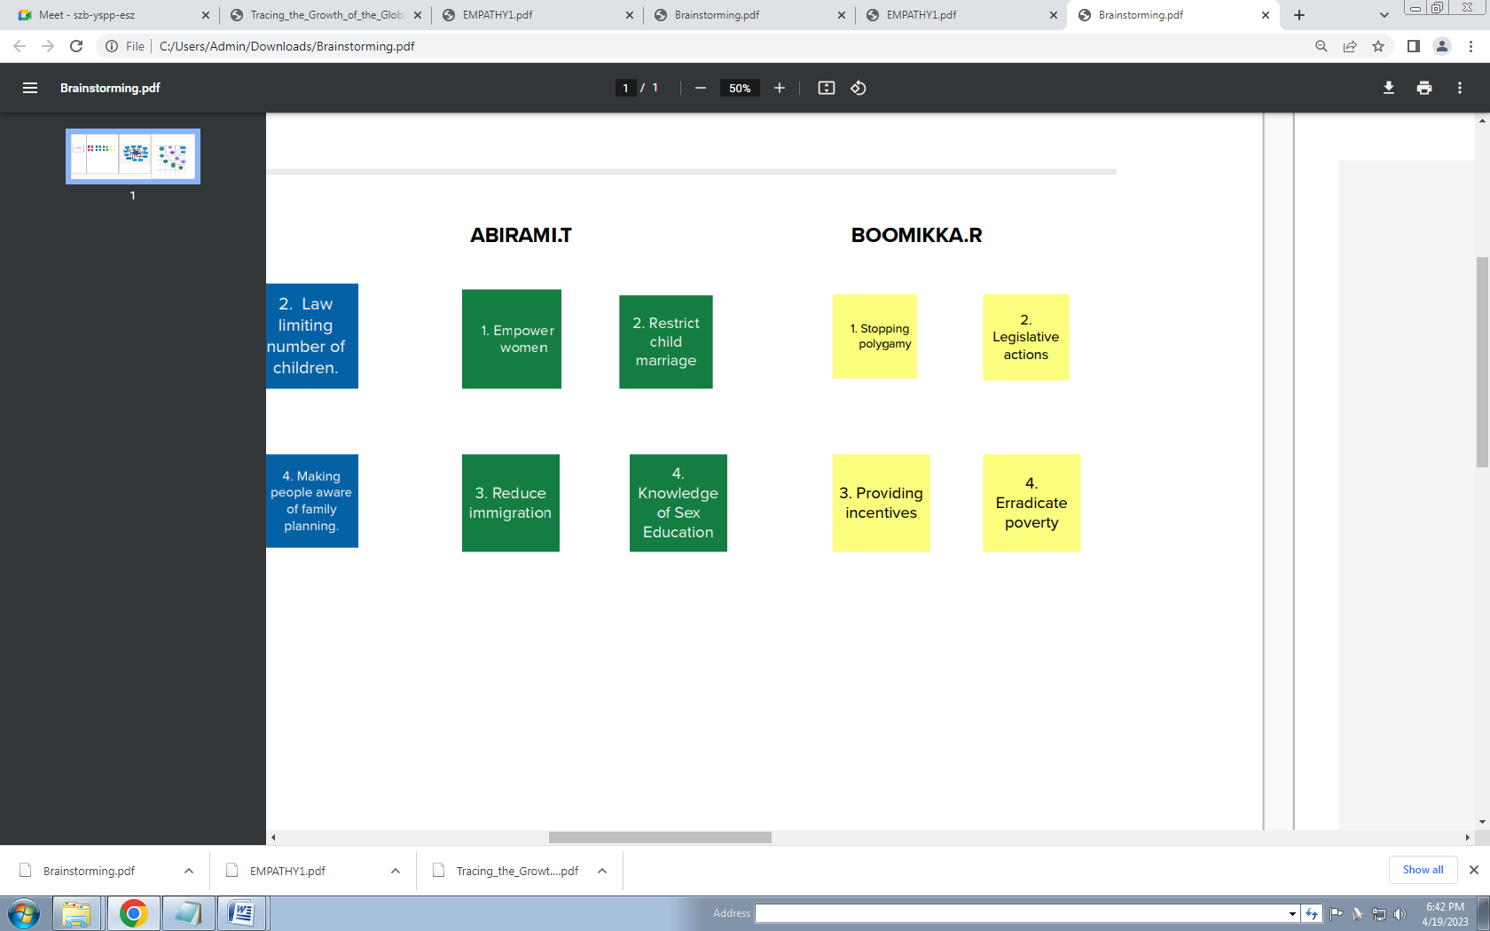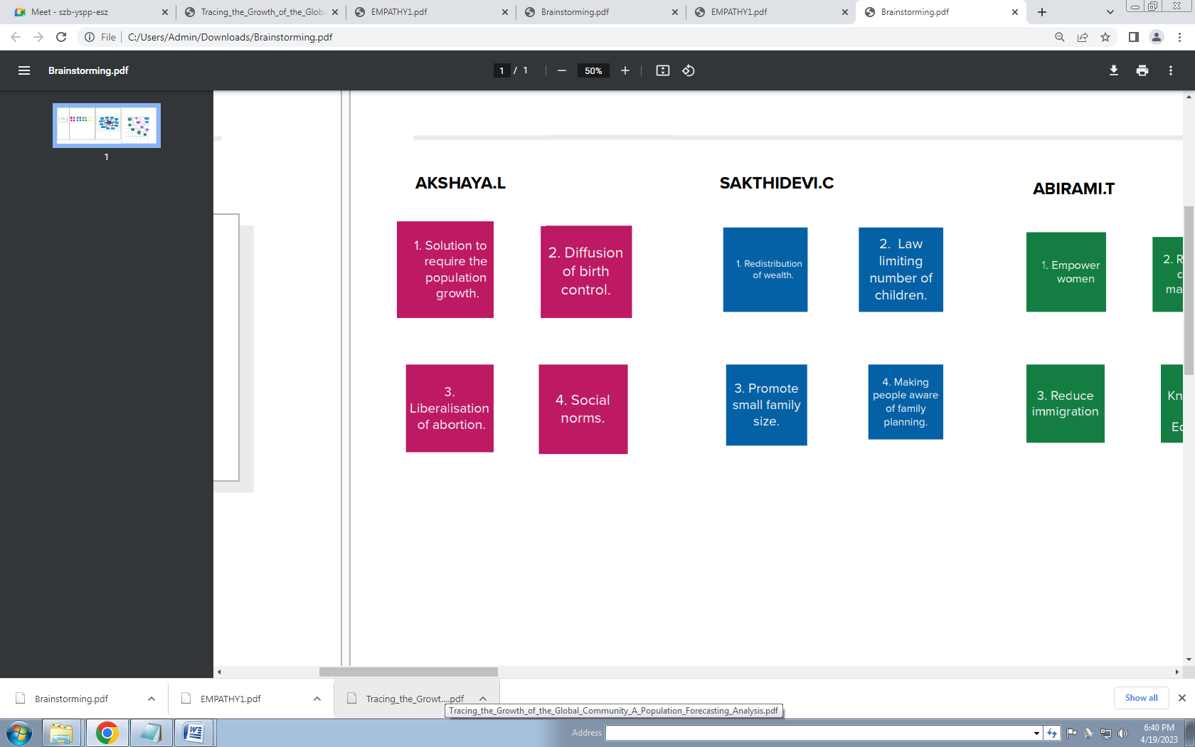

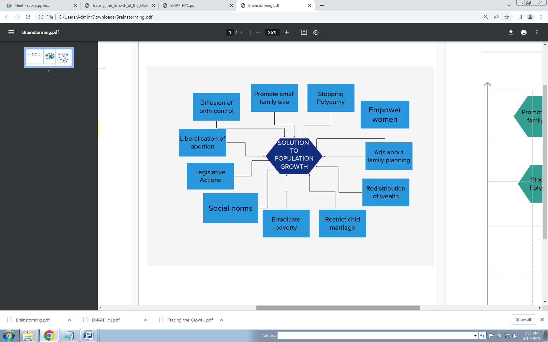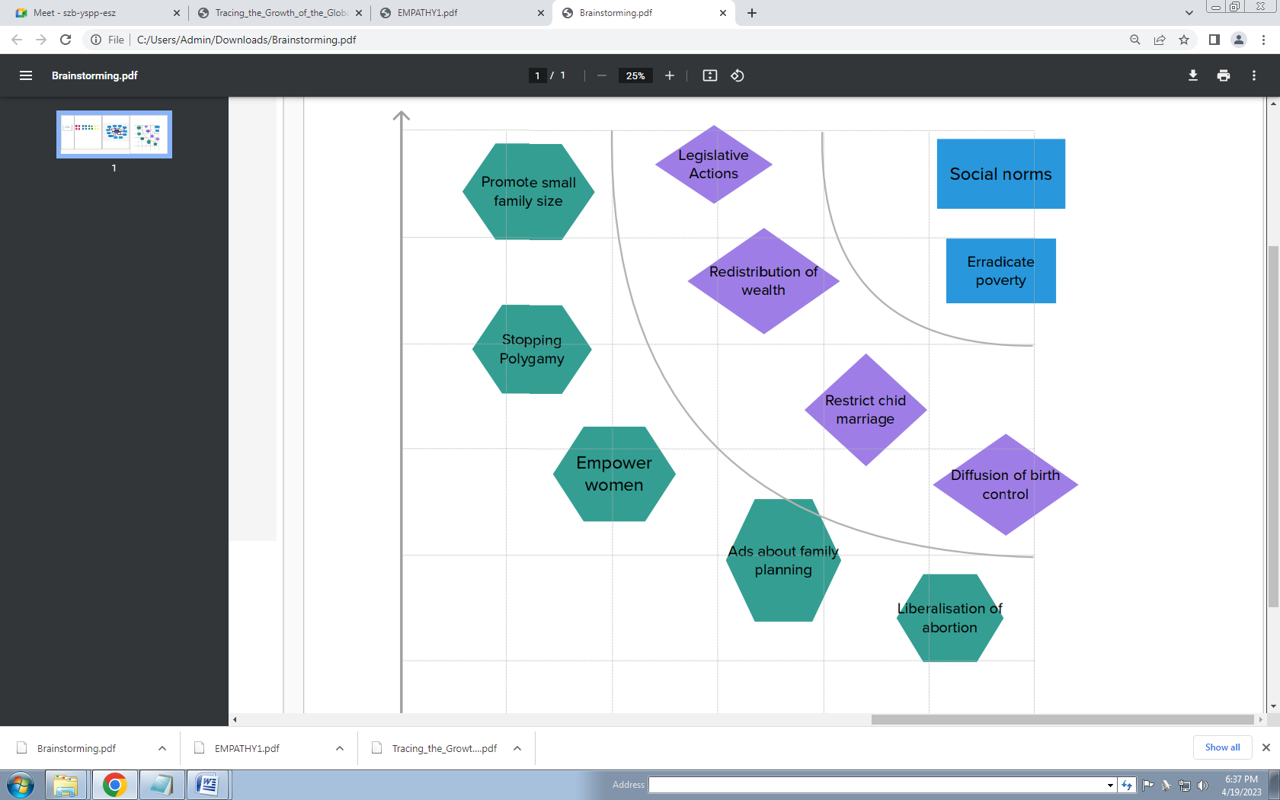

3.RESULT:

# DASHBOARD

A dashboard is a graphical user interface (GUI) that displays information and data in an organized, easy-to-read format. Dashboards are often used to provide real-time monitoring and analysis of data, and are typically designed for a specific purpose or use case. Dashboards can be used in a variety of settings, such as business, finance, manufacturing, healthcare, and many other industries. They can be used to track key performance indicators (KPIs), monitor performance metrics, and display data in the form of charts, graphs, and tables

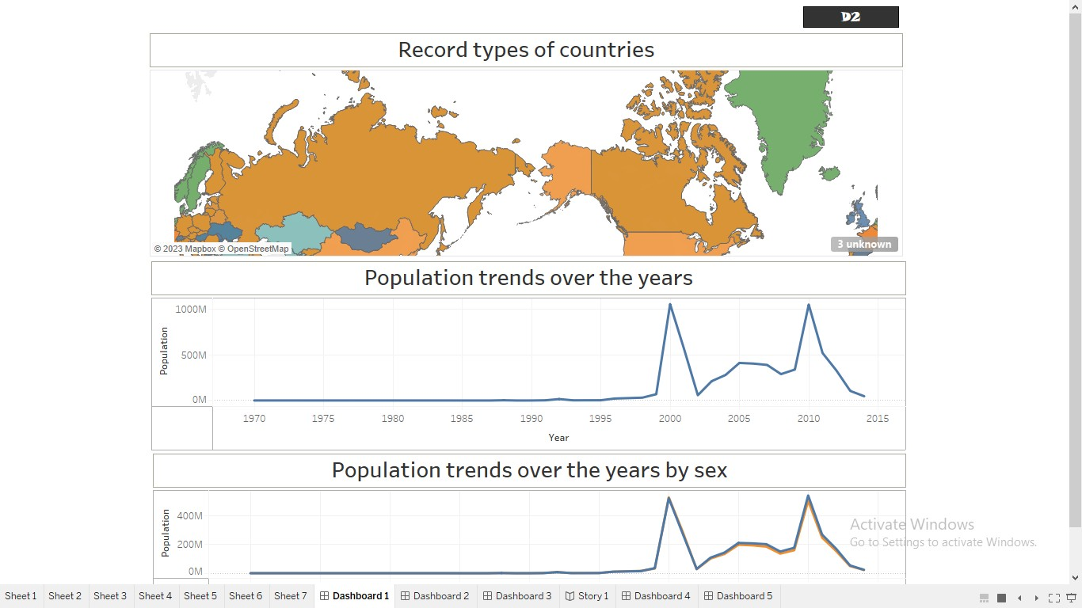

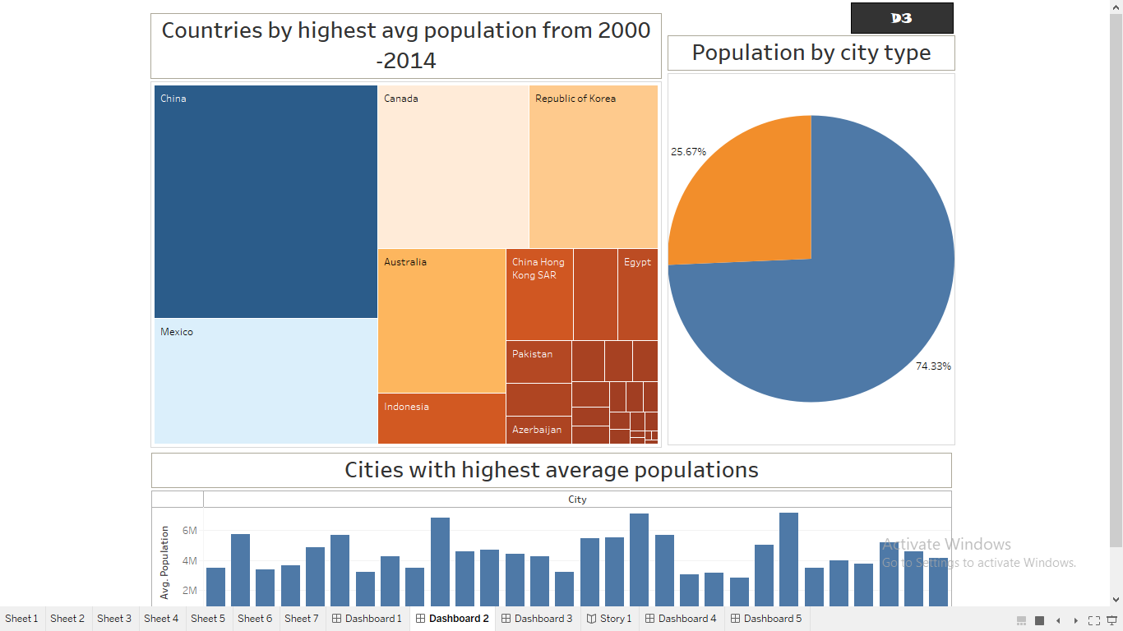

# STORY

A data story is a way of presenting data and analysis in a narrative format, with the goal of making the information more engaging and easier to understand. A data story typically includes a clear introduction that sets the stage and explains the context for the data, a body that presents the data and analysis in a logical and systematic way, and a conclusion that summarizes the key findings and highlights their implications. Data stories can be told using a variety of mediums, such as reports, presentations, interactive visualizations, and videos.

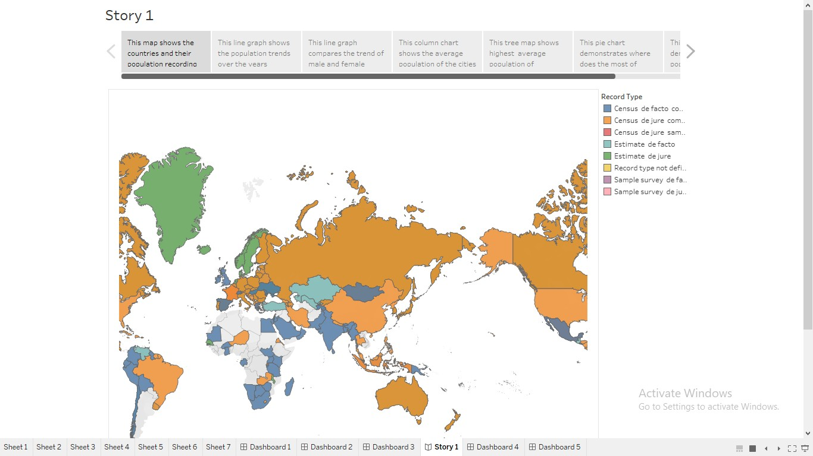

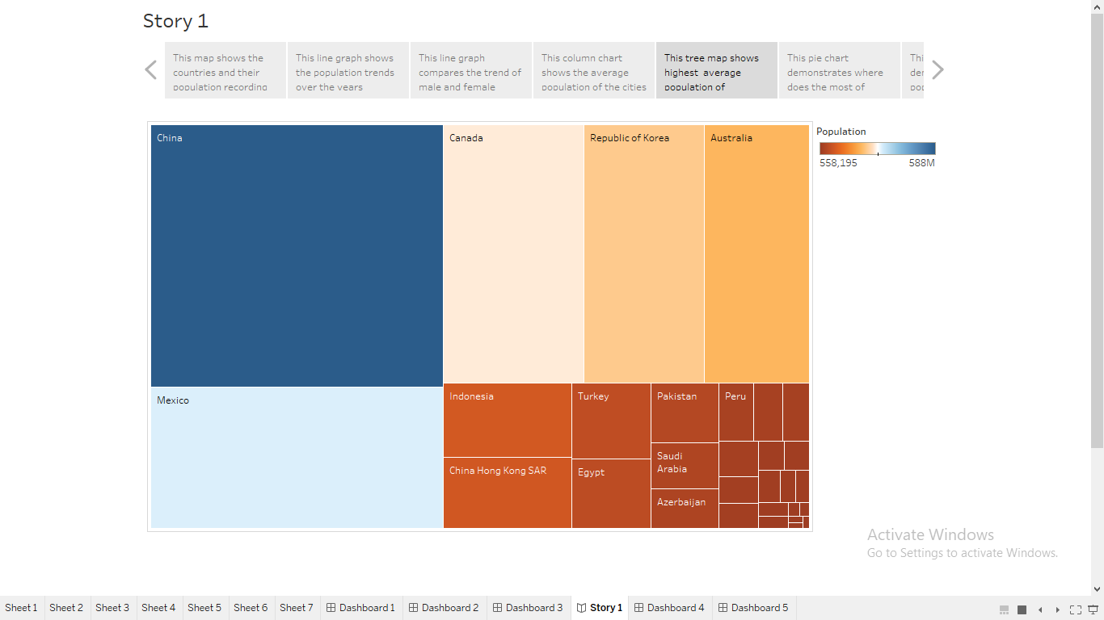

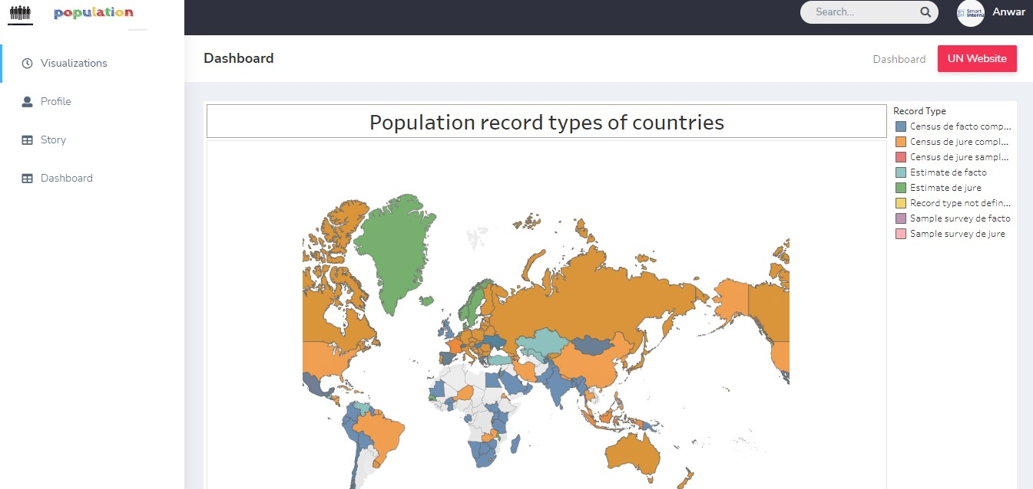WEB INTEGRATION

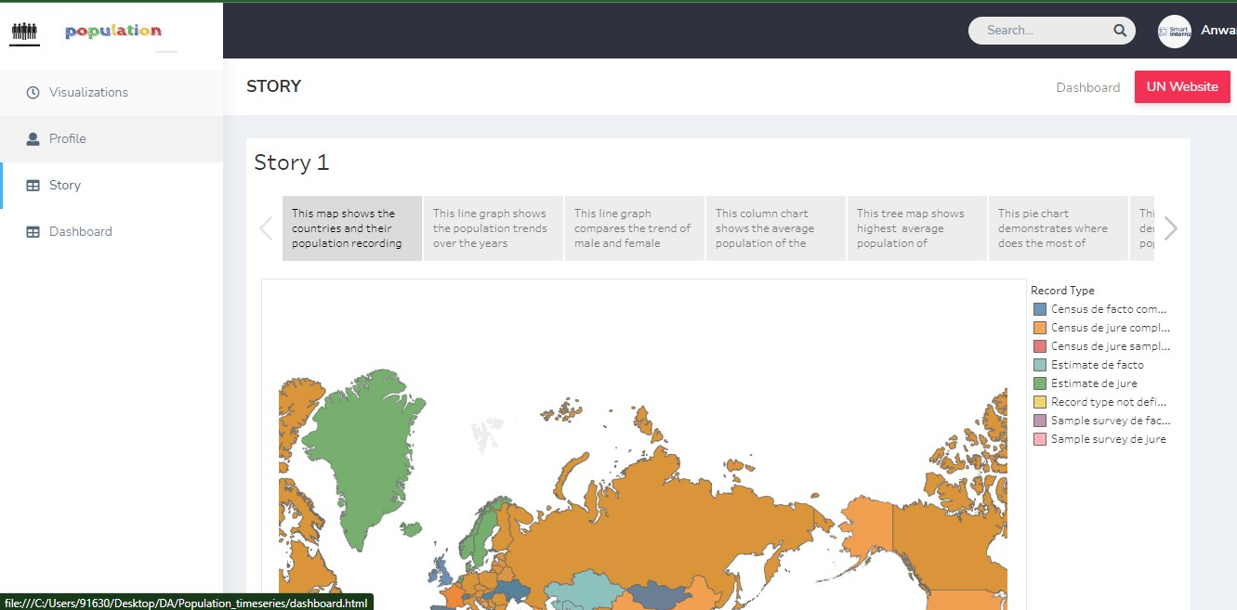

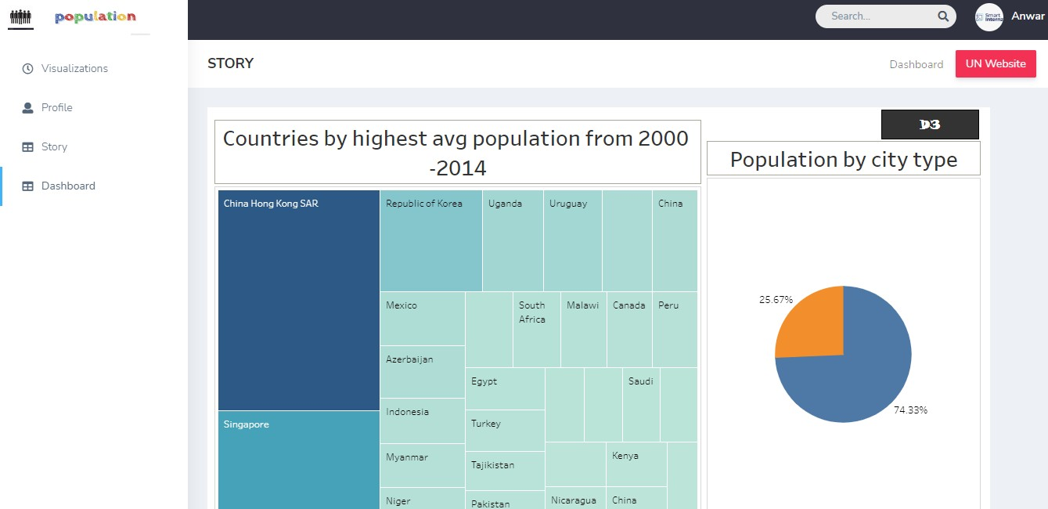

4. ADVANTAGES:

1. More people leads to greater human capital. If there are more people, the probability of finding a genius like Einsterin, Marie Curie, Beethoven increase. These exceptional people can lead to technological and cultural masterpieces which enrich our lives. The past 200 years have shown exponential growth in technical development and innovation. There are many factors behind this, but the world’s growing population means we have a bigger pool of human capital and the possibility of these cutting edge discoveries increase.

2. Higher economic growth. Population growth will lead to economic growth with more people able to produce more goods. It will lead to higher tax revenues which can be spent on public goods, such as health care and environmental projects.

3. The improved demographic structure of society. Many western economies are now experiencing a falling population, with the result that their population demographic is being skewed to old, retired people. This is imposing costs on society as we struggle to pay for health care and pensions. Moderate population growth helps to rebalance the population with a higher share of young, working people.

4. Critical mass. Higher populations can enable a critical mass of people to enable a sider, more vibrant society. With low populations, there is less scope for diversity. But, when the population grows, it can enable the support of a broader cultural range of activities

DISADVANTAGES:

1. Cost to the environment. Population growth exacerbates many of the existing environmental problems

2. Trying to reduce carbon and methane emissions to reduce global warming is relatively more difficult as the population.

3. There will be greater threat on natural habitats as a greater population has greater demand for housing and farmland. This will increase pressure to cut down forests to make way for farming and housing.

4. Higher population will lead to a greater consumption of non-renewable resources, leading to a faster depletion of natural resources.

5. APPLICATION:

The main purpose of producing population projections is to provide an estimate of the future population as a common framework for use in planning, policy formation and decision making in a number of different fields. Uses of projections include, but are not limited to:

* All projections are used in producing household projections
* National population projections (NPP) are a key input to the Office for Budget Responsibility long-term fiscal projections published in the fiscal sustainability report
* NPP are used to produce forecasts of expenditure for benefits and pensions and as a key input for analysis on policy areas such as extending working lives
* NPP are used as the basis for Department for Education projections of future school pupil numbers

6.CONCLUSION:

The population of india is around 140 crores. According to the certain reports, in the next few years, there will be a solid growth of population in India and globally too. The population is the total no. of. human beings living in the city or the country

7.FUTURE SCOPE:

**Fertility rates**: Future population growth is highly dependent on the path that future fertility will take. According to the World Population Prospects (2022 Revision), global fertility is projected to fall from 2.3 children per woman in 2021 to 2.1 in 2050.

**Increasing longevity :** Overall, significant gains in life expectancy have been achieved in recent years. Globally, life expectancy at birth is expected to rise from 72.8 years in 2019 to 77.2 years in 2050. While considerable progress has been made in closing the longevity differential between countries, large gaps remain. In 2021, life expectancy at birth in the least developed countries lags 7 years behind the global average, due largely to persistently high lev…

**United Nations role in population issues:** The United Nations system has long been involved in addressing these complex and interrelated issues – notably, through the work of the UN Population Fund (UNFPA) and the UN Population Division of the Department of Economic and Social Affairs.

**UN Population Division:** The UN Population Division of the Department of Economic and Social Affairs pulls together information on such issues as international migration and development, urbanization, world population prospects and policies, and marriage and fertility statistics. It supports UN bodies such as the Commission on Population and Development, and supports implementation of the Programme of Action adopted by the 1994 International Conference on Population and Development (IPCD).

8.APPENDIX:

[TRACING THE GLOBAL COMMUNITY.pptx](TRACING%20THE%20GLOBAL%20COMMUNITY.pptx)